**FINAL PROJECT REPORT**

Industry-specific intelligent fire management system

|  |  |
| --- | --- |
| **Team ID** | PNT2022TMID12783 |
| **Team Leader** | KARTHIKEYAN S |
| **Team Member 1** | DHINESH P |
| **Team Member 2** | DHARSHNA BALA G |
| **Team Member 3** | BARATH P |

**TABLE OF CONTENTS**

|  |  |  |  |  |  |  |  |  |
| --- | --- | --- | --- | --- | --- | --- | --- | --- |
| **Sl No.** | | | | **Title** | **Page**  **No.** | | | |
|  | 1. |  | | **INTRODUCTION** |  | | 4 | |
|  |
|  | | | | 1.1 Project Overview |  | | 4 | |
|  | | | | 1.2 Purpose |  | | 5 | |
|  | 2. |  | | **LITERATURE SURVEY** |  | | 6 | |
|  |
|  | | | | 2.1 Existing problem |  | | 6 | |
|  | | | | 2.2 References |  | | 7 | |
|  | | | | 2.3 Problem Statement Definition |  | | 8 | |
|  | 3. |  | | **IDEATION & PROPOSED SOLUTION** |  | | 9 | |
|  |
|  | | | | 3.1 Empathy Map Canvas |  | | 9 | |
|  | | | | 3.2 Ideation & Brainstorming | 1 | | 0 |  |
|  |
|  | | | | 3.3 Proposed Solution | 1 | | 4 |  |
|  |
|  | | | | 3.4 Problem Solution fit | 1 | | 5 |  |
|  |
|  | 4. |  | | **REQUIREMENT ANALYSIS** | 1 | | 6 |  |
|  |
|  |
|  | | | | 4.1 Functional requirement | 1 | | 6 |  |
|  |
|  | | | | 4.2 Non-Functional requirements | 1 | | 6 |  |
|  |
|  | 5. |  | | **PROJECT DESIGN** | 1 | | 7 |  |
|  |
|  |
|  | | | | 5.1 Data Flow Diagrams | 1 | | 7 |  |
|  |
|  | | | | 5.2 Solution & Technical Architecture | 1 | | 7 |  |
|  |
|  | | | | 5.3 User Stories | 2 | | 0 |  |
|  |
|  | 6. |  | | **PROJECT PLANNING & SCHEDULING** | 2 | | 1 |  |
|  |
|  |
|  | | | | 6.1 Sprint Planning & Estimation | 2 | | 1 |  |
|  |
|  | | | | 6.2 Sprint Delivery Schedule | 2 | | 3 |  |
|  |
|  | 7. |  | | **CODING & SOLUTIONING (Explain the features added in the project along with code)** | 2 | | 4 |  |
|  |
|  |
|  | | | | 7.1 Feature 1 | 2 | | 4 |  |
|  |
|  | | | | 7.2 Feature 2 | 2 | | 6 |  |
|  |
|  | | |  | 7.3 Database Schema (if Applicable) |  | 32 | |  |
|  | |
|  | 8. |  |  | **TESTING** |  | 33 | |  |
|  | |
|  |
|  | | |  | 8.1 Test Cases |  | 33 | |  |
|  | |
|  | | |  | 8.2 User Acceptance Testing |  | 34 | |  |
|  | |
|  | 9. |  |  | **RESULTS** |  | 35 | |  |
|  | |
|  |
|  | | |  | 9.1 Performance Metrics |  | 35 | |  |
|  | |
|  | 10. | |  | **ADVANTAGES & DISADVANTAGES** |  | 37 | |  |
|  | |
|  | |
|  | 11. | |  | **CONCLUSION** |  | 39 | |  |
|  | |
|  | |
|  | 12. | |  | **FUTURE SCOPE** |  | 39 | |  |
|  | |
|  | |
|  | 13. | |  | **APPENDIX** |  | 40 | |  |
|  | |
|  | |
|  | | | 14 | Source Code |  | 40 | |  |
|  | |
|  | | | 15 | GitHub |  | 42 | |  |
|  | |

**1.INTRODUCTION**

## 1.1 Project Overview

The primary purpose of fire alarm system is to provide an early warning of fire so that people can be evacuated & immediate action can be taken to stop or eliminate of the fire effect as soon as possible. Alarm can be triggered by using detectors or by manual call point (Remotely). To alert/evacuate the occupants siren are used. With the Intelligent Building of the rapid development of technology applications, commercial fire alarm market demand growth, the key is to use the bus system intelligent distributed computer system fire alarm system, although installation in the system much easier than in the past , but still cannot meet the modern needs, the installation costs of equipment costs about 33% ~ 70. The suggested technique in Fire alarm system used the addressable detectors units besides using the wireless connection between the detector in zones as a slave units and the main control unit as the master unit. The system shall include a control panel, alarm initiating devices, notification appliances, and the accessory equipment necessary for a complete functioning fire alarm system. In the wireless fire alarm, individual units are powered by primary

& secondary batteries for the communication.

**1.2 Purpose**

Fire alarm systems are only effective if they can generate reliable and fast fire alerts with exact location of fire. There is a direct correlation between the amount of damage caused by fire and interventions time in various fire alarm systems. As the time of intervention decreases, the damage also decreases. Hence the most important factor in a fire alarm system is the reaction or response time of fire alarm system, that is, the time between fire detection and extinguishing.

The earliest recorded examples of fire protection can be traced back to the Roman Empire and the catastrophic fires that started in Rome. As a result, Emperor Neron has adopted regulations that required fireproof material for walls and buildings restoration to be used. The second recorded case of adopting fire protection regulations occurred in the year 1666, after the Great fire of London, which destroyed more than 80% of the city. The fire of London spurred interest in the development of the first equipment for fire suppression in the form of hand pumps and fire hydrant installation for water supply.

**2. LITERATURE SURVEY**

## 2.1 Existing Problem

There are usually a number of construction and renovation works happening across a hospital complex at any one time, which often creates additional challenges for the fire system. Any works being carried out must be done without any downtime and minimal disruption as hospitals are operational 24 hours a day 365 days a year. Contractors can create copious amounts of dust that can set off smoke detectors, causing false alarms. This combined with maintenance work being carried out at night can cause a headache for healthcare estates staff as personnel must be called out of hours to correct it. One option to prevent these false alarms while ensuring fire safety is to temporarily replace smoke detectors for heat detectors in the area being worked in. Heat detectors or CO/ heat detectors are not prone to contamination and therefore are less likely to falsely activate due to dust. It is important to consider that smoke detectors’ coverage area is larger than a heat detectors and therefore a point for point replacement will result in a loss of coverage. Another option is to use a multisensor with multiple modes of sensitivity such as Apollo Soteria, this detector is much more resilient to false alarms due to its advanced chamber design and can, if required be switched to a heat only mode.

## 2.2 References

1. Ahmed Imteaj et.al. Studied the problems faced by factory workers in times when fire breaks out. They proposed a system using Raspberry Pi 3 which is capable of detecting fire and providing information about area of fire. The Raspberry Pi controls multiple Arduino boards which are connected with several motors and cameras to capture the fire incident.In this, they discussed about the modern technology that can be used to reduce extremely unfortunate accidents caused by fire. We designed thewhole system and calculated its effectiveness.

1. Ondrej Krejcar proposed a model for location enhancement and personnel tracking using Wi-Fi networks. In this, he has represented the control system concept that is used in handling information of location and control unit operations. The location of the user present in the building, is obtained through Wi-Fi access points. We have studied this to understand the usability of the Wi-Fi networks in live tracking and then have utilized this functionality to track fire and give information about location of fire to various devices intimating people about the mishap.

1. Authors in have studied the safety features in home and industrial areas. They have designed new model using WSN. Not only have they incorporated temperature and humidity sensors but also included fire and smoke sensors while developing the model. They present a preceding study of WSN is able to detect fire alarm. It is for setting up a wireless sensor network with three sensors. An application was developed for getting home information .

1. Azka Ihsan Nurrahman, Kusprasapta Mutijarsa have proposed a prototype for a centralized management system for homes or offices which helps better in managing the safety features. In this, home management system is required. This system controls the room lights by turning on and off automatically, it keeps the record of use of electronic device status, turning on and off the ac regulator automatically, it displays the room temperature in home. If fire is detected in the house, it turn on sprinkler at home, it supervises at home via surveillance cameras, take photos and store them including recordings of surveillance at home, it detects the movements of people at home, and provide notification when someone enters the house.

1. Building Fire Emergency Detection and Response Using Wireless Sensor Networks Yuanyuan Zeng, Seán Óg Murphy, Lanny Sitanayah, Tatiana Maria Tabirca, Thuy Truong, Ken Brown, Cormac J. Sreenan Department of Computer Science, University College Cork : Wireless sensor networks (WSNs) provide a low cost solution with respect maintenance and installation and in particular, building refurbishment and retrofitting are easily accomplished via wireless technologies. Fire emergency detection and response for building environments is a novel application area for the deployment of wireless sensor networks. In such a critical environment, timely data acquisition, detection and response are needed for successful building automation. This paper presents an overview of our recent research activity in this area. Firstly we explain research on communication protocols that are suitable for this problem. Then we describe work on the use of WSNs to improve fire evacuation and navigation.

## 2.3 Problem Statement Definition

* The smart fire management system includes a Gas sensor, Flame sensor and temperature sensors to detect any changes in the environment.
* Based on the temperature readings and if any Gases are present the exhaust fans are powered ON.
* If any flame is detected the sprinklers will be switched on automatically.
* Emergency alerts are notified to the authorities and Fire station.

# 3. IDEATION & PROPOSED SOLUTION

## 3.1 Empathy Map Canvas

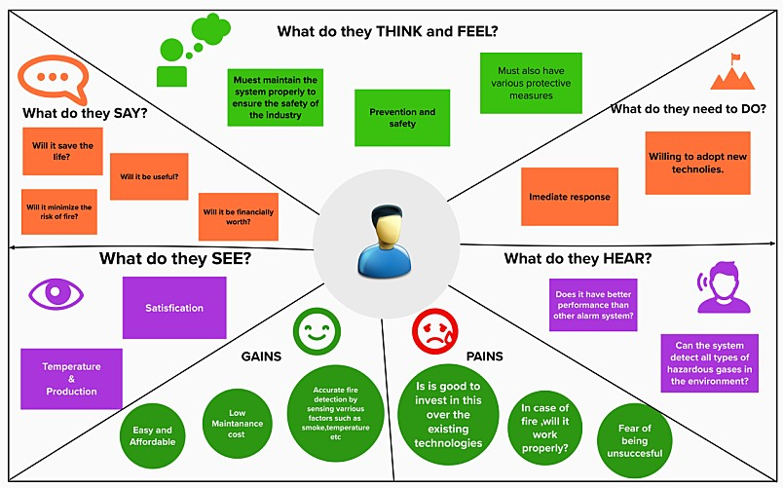

## 3.2 Ideation & Brainstorming

**Step-1: Team Gathering, Collabora on and Select the Problem Statement**

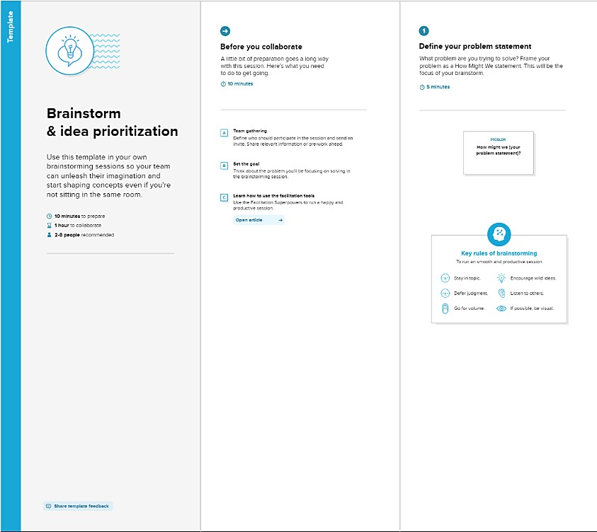

**Step-2: Brainstorm, Idea Lis ng and Grouping**

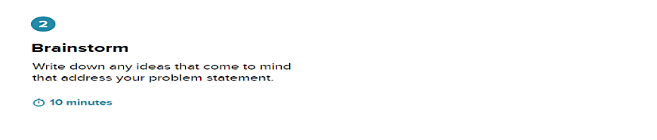

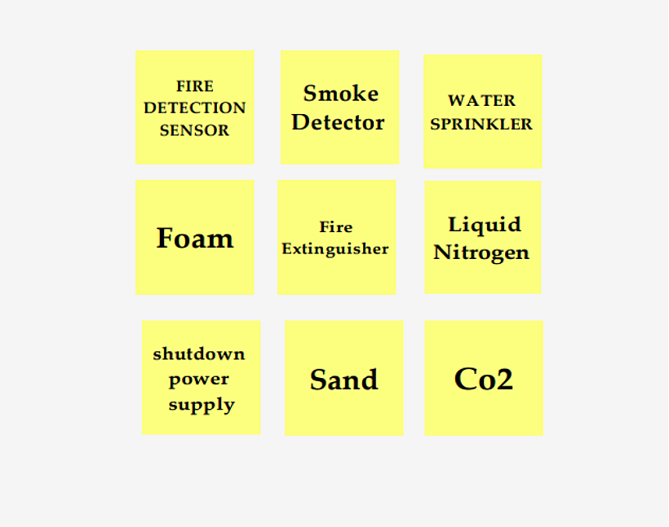

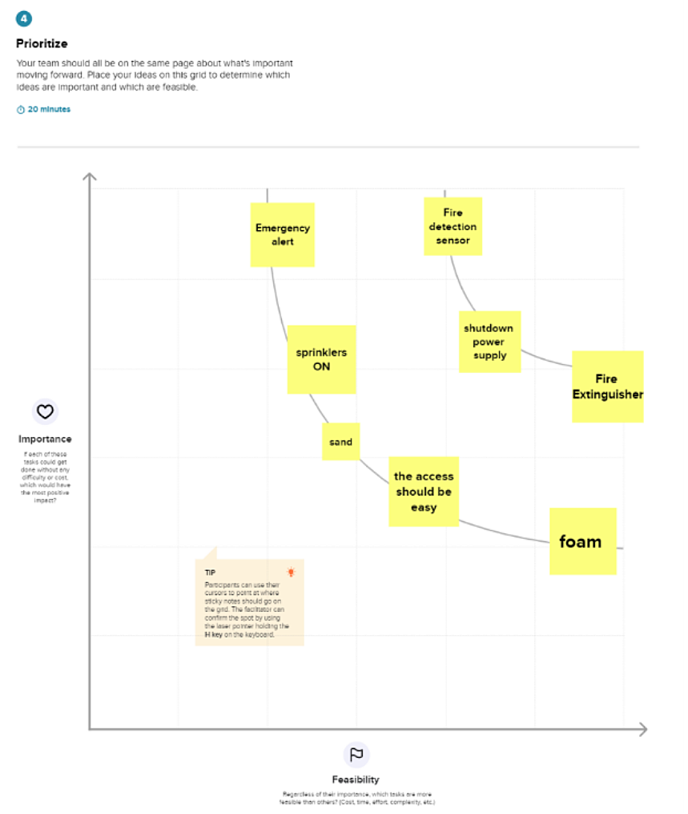

## 3.3 Proposed Solution

**Proposed Solu on Template:**

|  |  |  |
| --- | --- | --- |
| **S.No.** | **Parameter** | **Descrip on** |
| 1. | Problem Statement (Problem to be solved) | The main issues are unavailability of access for fire officers and poor roads. The inconsistencies are also related to the poor performance of the ac ve and passive protec on system, which in most cases fails to func on in accordance with fire safety standards. |
| 2. | Idea / Solu on descrip on | Don't overload electrical equipment or circuits. Don't leave temporary equipment plugged in when it's not in use. Avoid using extension cords, and never consider them permanent solu ons. Use an sta c equipment where required by NFPA or OSHA. |
| 3. | Novelty / Uniqueness | An integrated system of temperature monitering, gas monitering, fire detec on and automa c sprinklers to obtain the accurate informa on about loca ons and response through SMS no fica on and call. |
| 4. | Social Impact / Customer Sa sfac on | Forecas ng the mishap will no fy the industry workers to migrate to be er and safer buildings. Provides components with affordable prices and is highly feasible. |
| 5. | Business Model (Revenue Model) | It is an industry-efficient product in all aspects. Provides a clear idea about the en re working mechanism of the system. |
| 6. | Scalability of the Solu on | This is complete system makes it easily expandable and business efficient for the fire detec on, with the significant cost. |

## 3.4 Problem Solution Fit

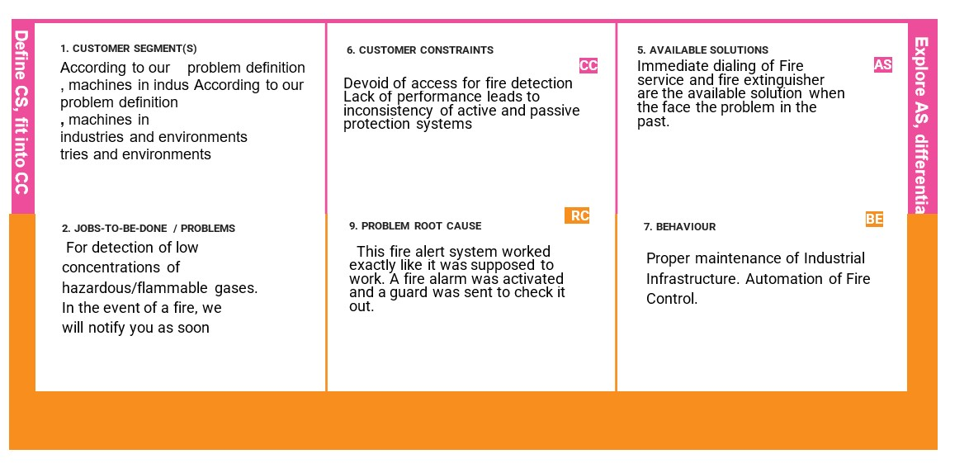

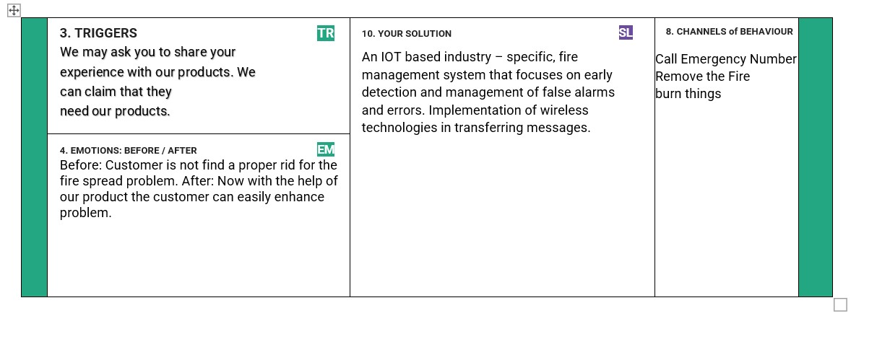

# 4.REQUIREMENT ANALYSIS

## 4.1 Functional requirement

Following are the func onal requirements of the proposed solu on.

|  |  |  |
| --- | --- | --- |
| **FR No.** | **Func onal Requirement (Epic)** | **Sub Requirement (Story / Sub-Task)** |
| FR-1 | User Registra on | Registra on via form  Registra on via mobile phone number |
| FR-2 | User Confirma on | Confirm by message  Confirm by phone |
| FR-3 | User Login | Log in through the website or app with your respec ve username and password. |
| FR-4 | User Upload | Customers should be able to upload informa on |
| FR-5 | Fire Detec on Monitoring | Sensors monitor the industry 24/7 and the provides informa on to end users. |
| FR-6 | Loca on No fica on | The loca on of the fire is sent to the fire brigade in an alarm or message |

## 4.2 Non Functional Requirement

Following are the non-func onal requirements of the proposed solu on.

|  |  |  |
| --- | --- | --- |
| **FR No.** | **Non-Func onal Requirement** | **Descrip on** |
| NFR-1 | **Usability** | Easy to use and economical Easy |
| NFR-2 | **Security** | Protect your so ware from a acks |
| NFR-3 | **Reliability** | Fast response mer. Highly reliable.  Applica on is running correctly |
| NFR-4 | **Performance** | If a fire is detected, you will be no fied immediately through the web applica on and tracking will also be done regularly. |
| NFR-5 | **Availability** | Availability of the system in ins tu ons , restaurants and other public places. |
| NFR-6 | **Scalability** | It can be easily modified to suit different needs. |

# 5.PROJECT DESIGN

## 5.1 Data Flow Diagrams

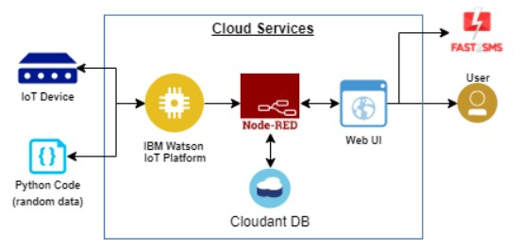

## 5.2 Solution & Technical Architecture

**Table-1: Components&Technologies:**

|  |  |  |  |
| --- | --- | --- | --- |
| **S.No** | **Component** | **Description** | **Technology** |
| 1. | User Interface | Web UI ,Node-RED, MITapp | IBM IoT  Platform, IBM Node red, IBM Cloud |
| 2. | ApplicationLogic-1 | Create Ibm Watson IoT platform and create node- red service | Ibm Watson ,ibm cloudant service, ibm node-red |
| 3. | ApplicationLogic-2 | Develop python script to publish and subscribe to IBM IoT Platform | python |
| 4. | ApplicationLogic-3 | Build a web application using | IBM Node-red |
|  |  | node-red service |  |
| 5. | Database | Data Type, Configuration set c. | MySQL |
| 6. | Cloud Database | Database Service on Cloud | IBMDB2, IBM  Cloudant |
| 7. | File Storage | Developing mobile application to store and receive the sensors information and to react accordingly | Web UI, python |
| 8. | ExternalAPI-1 | Using this IBM fire management API we can track  the temperature of the incident place and where the fire had been attacked. | IBM fire management API |
| 9. | ExternalAPI-2 | Using this IBM Sensors it detects the fire,  Gas leaks, temperature and provides the activation of sprinklers to web UI | IBM Sensors |
| 10. | MachineLearningModel | Using this we can derive the object recognition model | Object Recognition Model |
| 11. | Infrastructure(Server/Cloud) | Application Deployment on Local  System / Cloud Cloud Server  Configuration | IBM cloudant, IBM  IoT Platform |

**Table-2:ApplicationCharacteristics:**

|  |  |  |  |
| --- | --- | --- | --- |
| **S.No** | **Characteristics** | **Description** | **Technology** |
| 1. | Open-Source Frameworks | MIT app Inventor | MIT License |
| 2. | Security Implementations | IBM Services | Encryptions, IBM Controls |
| 3. | Scalable Architecture | sensor-IoT Cloud based architecture | Cloud compu ng and AI |
| 4. | Availability | Mobile ,laptop, desktop | MIT app |
| 5. | Performance | Detects the Fire, gasleak, temperature | sensors |

## 5.3 User Stories

|  |  |  |  |  |  |  |  |  |  |  |  |  |  |  |  |
| --- | --- | --- | --- | --- | --- | --- | --- | --- | --- | --- | --- | --- | --- | --- | --- |
| **User Type** | **Functional**  **Requireme nt (Epic)** | **User**  **Story**  **Numb er** | **User Story / Task** | | | | |  | **Acceptance criter** | | | | **ia** | **Priority** | **Release** |
| Customer (Mobile user) | Registration | USN-1 |  | As a user, you can register in the | | | |  |  | Can access my |  | |  | High | Sprint-1 |
| application by entering your email address, password, and confirming the password. | | | | account/dashboard. |
|  |  | USN-2 |  | As a user, you will receive a |  | | |  |  | You will receive a | |  |  | High | Sprint-1 |
| confirmation email after registering in the application | confirmation email and can click Confirm. | |
|  |  | USN-3 |  | As a user, you can register in the | | |  |  |  | You can register with | | |  | Low | Sprint-2 |
| application via Facebook. | | | your Facebook login to access your dashboard | | |
|  |  | USN-4 |  | As a user, you can register in | | |  |  |  | | | |  | Medium | Sprint-1 |
| the application via Gmail. | | |
|  | Login | USN-5 |  | As a user, you can login to the | |  | |  |  | | | |  | High | Sprint-1 |
| application by entering your email and password | |
|  | Dashboard |  |  | | | | |  |  | | | |  |  |  |
| Customer  (Web user) |  |  |  | | | | |  |  | | | |  |  |  |
| Customer  Care  Executive |  |  |  | | | | |  |  | | | |  |  |  |
| Administrator |  |  |  | | | | |  |  | | | |  |  |  |

**6. PROJECT PLANNING & SCHEDULING**

## 6.1 Sprint Planning & Estimation

|  |  |  |  |  |  |  |  |  |
| --- | --- | --- | --- | --- | --- | --- | --- | --- |
| **Sprint** | **Functional**  **Requirement**  **(Epic)** | **User Story Number** | **User Story / Task** | | | **Story**  **Points** | **Priority** | **Team**  **Members** |
| Sprint-1 | Registration | USN-1 | As a user, you can  register in the application  by entering your email address,  password, and  confirming the password. | | | 2 | High | Karthikeyan |
| Sprint-2 | Registration | USN-2 |  | As a user, you |  | 3 | Medium | Dhinesh ,Barath |
| will receive a confirmation email after  registering in the  application. |
| Sprint-3 | Registration | USN-3 | As a user, you can register in the  application via  Facebook | | | 1 | Low | Dharshna bala |
|  | | |

|  |  |  |  |  |  |  |  |  |  |  |  |  |  |  |  |
| --- | --- | --- | --- | --- | --- | --- | --- | --- | --- | --- | --- | --- | --- | --- | --- |
| Sprint-2 | Registration | US  N-4 |  | As a user, you can | | | | | | |  | | 1 | High | Dharshna bala |
| register in the  application via  Gmail. | | | | | | |
| Sprint-4 | Login | US  N-5 |  | As a user, you can | | | | | | |  | | 5 | High | Dhinesh P |
| login to the  application by  entering your email and password. | | | | | | |
| Sprint-1 | Dashboard | US  N-6 |  | As a user, you can | | | | | | | |  | 1 | Medi um | Barath P |
| receive notifications. | | | | | | | |
| Sprint-3 | Testing & Deployment Phase-I | US  N-7 |  | | | | System | e | | | | | 8 | High | Karthikeyan |
| performance  testing. Use for  emergenci  s. |
| Sprint-3 | Testing & Deployment Phase-I | US  N-8 |  | | | Make sure the | | | | e    ser | | | 2 | High | Dhinesh P |
| system detects fir and gas correctly.  Additionally, the u will be notified. | | | |
| Sprint-1 | Deployment  Phase-II  &Model Improve ment | US  N-9 |  | | By providing an | | | | | | y-  ol  m  nd | | 1 | Low | Barath P |
| IOT-based industr specific fire contr system, the syste  can be checked a used 24/7. | | | | | |
| Sprint-2 | Verification | US  N-10 |  | Administrators | | | | |  | | | | 5 | High | Dharshna bala |
| have full  visibility of submitted applications. | | | | |
| Sprint-3 | Approval | US  N-11 |  | After completion, | | | | | | |  | | 2 | High | Barath P |
| the customer will be provided with  new bank access  data. | | | | | | |

## 6.2 Sprint Delivery Schedule

|  |  |  |  |  |  |  |
| --- | --- | --- | --- | --- | --- | --- |
| **Sprint** | **Total Story Points** | **Duration** | **Sprint**  **Start Date** | **Sprint End**  **Date**  **(Planned)** | **Story**  **Points**  **Completed**  **(as on**  **Planned**  **End**  **Date)** | **Sprint Release Date(Actual)** |
| Sprint-1 | 20 | 6 Days | 24 Oct 2022 | 29 Oct  2022 | 20 | 12 nov 2022 |
| Sprint-2 | 20 | 6 Days | 31 Oct 2022 | 05 Nov  2022 | 20 | 14 Nov 2022 |
| Sprint-3 | 20 | 6 Days | 07 Nov 2022 | 12 Nov  2022 | 20 | 15 Nov 2022 |
| Sprint-4 | 20 | 6 Days | 14 Nov 2022 | 19 Nov  2022 | 20 | 17 Nov 2022 |

# 7. CODING & SOLUTIONING

## 7.1 Feature 1

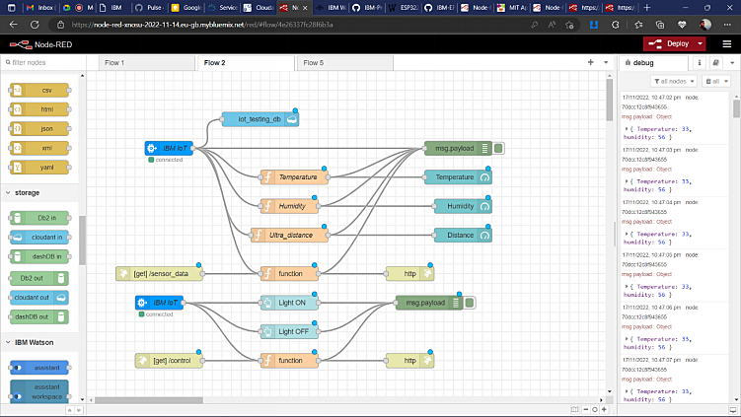

## 7.1 Feature 1

## 7.2 Feature 2

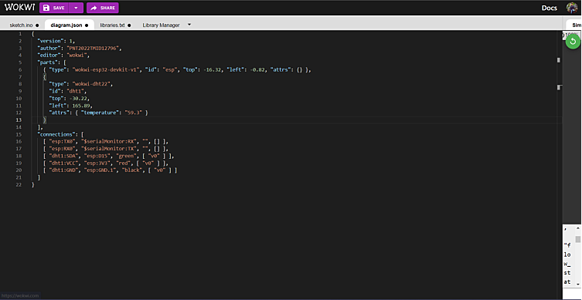

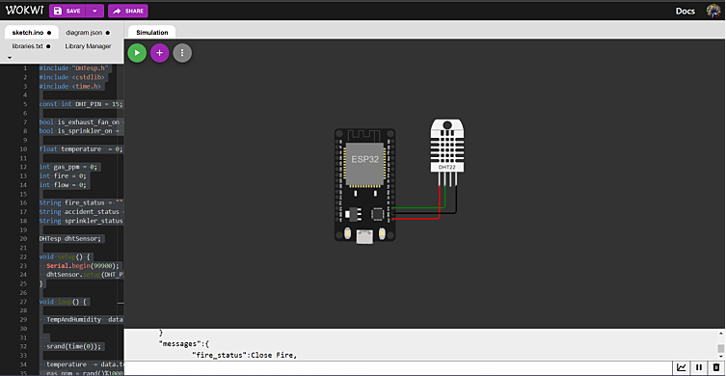

**PROGRAM**

**#include "DHTesp.h"**

**#include <cstdlib>**

**#include <time.h>**

**const int DHT_PIN = 15;**

**bool is_exhaust_fan_on = false;** **bool is_sprinkler_on = false;**

**float temperature = 0;**

**int gas_ppm = 0;**

**int fire = 0;** **int flow = 0;**

**String fire_status = "";**

**String accident_status = "";**

**String sprinkler_status = "";**

**DHTesp dhtSensor;**

**void setup() {**  **Serial.begin(99900);**

**dhtSensor.setup(DHT_PIN, DHTesp::DHT22);**

**}**

**void loop() {**

**TempAndHumidity data = dhtSensor.getTempAndHumidity();**

**srand(time(0));**

**temperature = data.temperature;**

**gas_ppm = rand()%1000;**

**int firereading = rand()%1024;**

**fire = map(firereading,0,1024,0,1024);**

**int firerange = map(firereading,0,1024,0,3);**

**int flow = ((rand()%100)>50?1:0);**

**switch (firerange) {**

**case 2:**

**fire_status = "Close Fire";**

**break;**

**case 1:**

**fire_status = "Distant Fire";**

**break;**

**case 0:**

**fire_status = "No Fire";**

**break;**

**}**

**if(gas_ppm > 100){**

**is_exhaust_fan_on = true;**

**}**

**else{**

**is_exhaust_fan_on = false;**

**}**

**if(temperature < 40 && firerange ==2){**

**accident_status = "need auditing";**

**is_sprinkler_on = false;**

**}**

**else if(temperature < 40 && firerange ==0){**

**accident_status = "nothing found";**

**is_sprinkler_on = false;**

**}**

**else if(temperature > 50 && firerange == 1){**  **is_sprinkler_on = true;**

**accident_status = "moderate";**

**}**

**else if(temperature > 55 && firerange == 2){**

**is_sprinkler_on = true;**

**accident_status = "severe";**

**}else{**

**is_sprinkler_on = false;**

**accident_status = "nil";**

**}**

**if(is_sprinkler_on){**

**if(flow){**

**sprinkler_status = "working";**

**}**

**else{**

**sprinkler_status = "not working";**

**}**

**}**

**else if(is_sprinkler_on == false){**

**sprinkler_status = "now it shouldn't";**

**}**

**else{**

**sprinkler_status = "something's wrong";**

**}**

**String out = "{\n\t\"senor_values\":{";**

**out+="\n\t\t\"gas_ppm\":"+String(gas_ppm)+",";**

**out+="\n\t\t\"temperature\":"+String(temperature,2)+",";**

**out+="\n\t\t\"fire\":"+String(fire)+",";**

**out+="\n\t\t\"flow\":"+String(flow)+",\n\t}";**

**out+="\n\t\"output\":{";**

**out+="\n\t\t\"is_exhaust_fan_on\":"+String((is_exhaust_fan_on)?"true":"false")+",**

**";**

**out+="\n\t\t\"is_sprinkler_on\":"+String((is_sprinkler_on)?"true":"false")+",";**  **out+="\n\t}";**

**out+="\n\t\"messages\":{";**

**out+="\n\t\t\"fire_status\":"+fire_status+",";**

**out+="\n\t\t\"flow_status\":"+sprinkler_status+",";**

**out+="\n\t\t\"accident_status\":"+accident_status+",";**

**out+="\n\t}";**

**out+="\n}";**

**Serial.println(out);**

**delay(1000);**

**}**

## 7.3 Database Schema

# 8.Testing

## 8.1 Test Cases

**SL.NO** **INPUT** **OUTPUT** **RESULT**

|  |  |  |  |
| --- | --- | --- | --- |
| **01.** | Gas:519  Temperature:59.30  Flame:427 | Exhaust fan on:TRUE  Sprinklers:ON | Passed |
| **02.** | Gas:804  Temperature:59.30  Flame:589 | Exhaust fan on:TRUE  Sprinklers:ON | Passed |
| **03.** | Gas:738  Temperature:59.30  Flame:751 | Exhaust fan on:TRUE  Sprinklers:ON | Passed |
| **04.** | Gas:23  Temperature:59.30  Flame:913 | Exhaust fan on:FALSE  Sprinklers:ON | Passed |
| **05.** | Gas:308  Temperature:59.30  Flame:51 | Exhaust fan on:TRUE  Sprinklers:OFF | Passed |
| **06.** | Gas:241  Temperature:59.30  Flame:213 | Exhaust fan on:TRUE  Sprinklers:OFF | Passed |
| **07.** | Gas:527  Temperature:59.30  Flame:375 | Exhaust fan on:TRUE  Sprinklers:ON | Passed |
| **08.** | Gas:812  Temperature:59.30  Flame:537 | Exhaust fan on:TRUE  Sprinklers:ON | Passed |
| **09.** | Gas:745  Temperature: 59.30  Flame:699 | Exhaust fan on:TRUE  Sprinklers:ON | Passed |
| **10.** | Gas:31  Temperature:59.30  Flame:861 | Exhaust fan on:FALSE  Sprinklers:ON | Passed |
| **11.** | Gas:316  Temperature:59.30  Flame:1023 | Exhaust fan on:TRUE  Sprinklers:ON | Passed |

## 8.2 User Acceptance Testing

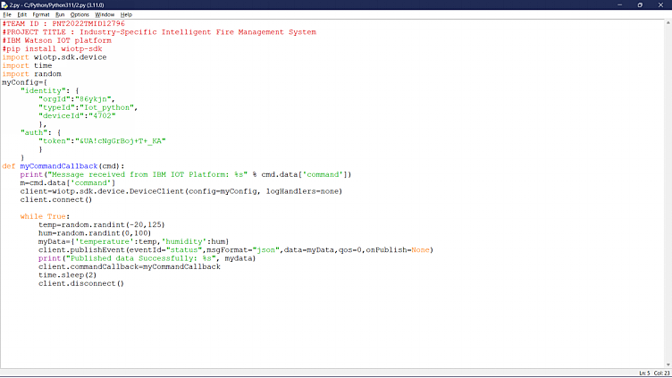

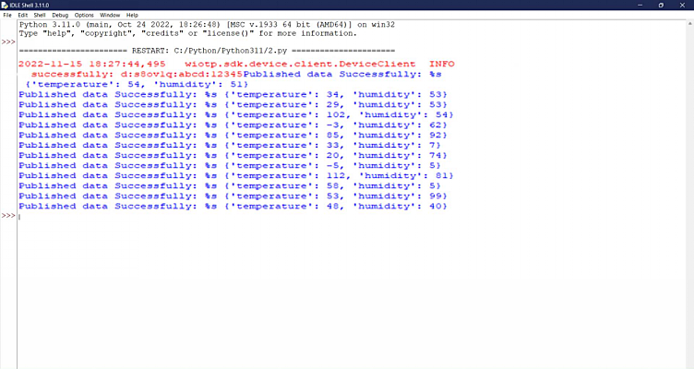

# 9.RESULTS

## 9.1 Performance Metrics





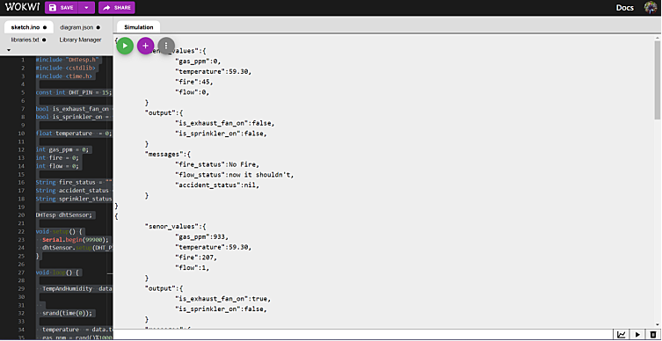

**10.ADVANTAGES & DISADVANTAGES**

# ADVANTAGES

* **Addressable fire alarm systems give information about individual detectors, whereas conventional systems only give information about specific circuits (zones).**

* **Addressable systems allow a courtesy text label to allow easy identification of any event. For instance, detector 1 may be given the label ‘Bedroom 1’.**

* **Most addressable systems allow an early ‘prealarm’ warning, which allows the responsible person to investigate potential alarms before the system activates its sirens.**

* **Many addressable systems can alter the alarm threshold of the detectors, in order to meet the needs of different environments in different areas of the system.**

* **Addressable systems are usually wired in a loop.**

* **Conventional systems are usually wired as radial circuits.**

* **Addressable systems usually have a real time clock & event log to record system events.**

* **Larger addressable systems usually have the ability to use sophisticated programming options to operate certain outputs only with specific events**

# DISADVANTAGES

* **The one thing most fire alarm system inspectors caution against with wireless systems is having to replace the battery. The system is essentially useless if the batteries aren’t charged, since it won’t work properly. There is a bit of a burden to homeowners or business owners to always remember to keep the batteries fresh so the system operates properly when you need it most.**

* **A couple other disadvantages fire alarm system inspectors point out is wireless systems have limited range and don’t have centralized monitoring. Range can be a problem for large offices or homes, since a weak wireless connection may cause the system to not operate reliably. Wireless fire alarm systems also don’t connect directly to the telephone lines, which are linked to the fire departments, so the response to an emergency could be slower as a result.**

# 11. CONCLUSION

There is a general agreement over the fire and protection segments that at 220,000 for every annum the degrees of bogus and undesirable alarms radiating from fire alarm and discovery frameworks is excessively high. Bogus and undesirable alarms squander fire and salvage administration assets; cause superfluous and costly interruption to end-clients which can bring about the loss of trust in frameworks and has seen a few frameworks turned off. As fire alarm and identifications frameworks are so firmly inserted into the clearing systems and strategies created to meet the necessities of Building Regulations and Fire Safety Law their utilization is far reaching and there are entrenched outsider accreditation plans for producers and installers. The item measures and testing systems anyway stay quiet on the reasons for bogus alarms.

# 12. FUTURE SCOPE

The scope of the fire safety systems market includes the type of safety system with fire detectors and suppressors, such as gas, foam, and detectors. The increasing focus of the government bodies on implementing fire safety equipment across various industries, such as chemical and petrochemical, oil and gas, pharmaceutical, aerospace, and defense, has led to the growth of the market studied.

**13.APPENDIX**

# Source Code

#include <WiFi.h>

#include <PubSubClient.h>

WiFiClient wifiClient;

String data3;

#define ORG "86ykjn"

#define DEVICE_TYPE "assignment4"

#define DEVICE_ID "12345"

#define TOKEN "6DGHyn)mYb)gRuXJvt"

#define speed 0.034 #define led 14

char server[] = ORG ".messaging.internetofthings.ibmcloud.com"; char publishTopic[] = "iot-2/evt/event2/fmt/json"; char topic[] = "iot-2/cmd/home/fmt/String"; char authMethod[] = "use-token-auth"; char token[] = TOKEN;

char clientId[] = "d:" ORG ":" DEVICE_TYPE ":" DEVICE_ID; PubSubClient client(server, 1883, wifiClient);

const int trigpin=5; const int echopin=18; String command;

String data="";

long duration;

float dist;

void setup()

{

Serial.begin(115200);

pinMode(led, OUTPUT);

pinMode(trigpin, OUTPUT);

pinMode(echopin, INPUT);

wifiConnect();

mqttConnect();

}

void loop() {

bool isNearby = dist < 100;

digitalWrite(led, isNearby);

publishData();

delay(500);

if (!client.loop()) {

mqttConnect();

}

}

void wifiConnect() {

Serial.print("Connecting to "); Serial.print("Wifi");

WiFi.begin("Wokwi-GUEST", "", 6);

while (WiFi.status() != WL_CONNECTED) {

delay(500);

Serial.print(".");

}

Serial.print("WiFi connected, IP address: "); Serial.println(WiFi.localIP());

}

void mqttConnect() {

if (!client.connected()) {

Serial.print("Reconnecting MQTT client to "); Serial.println(server);

while (!client.connect(clientId, authMethod, token)) {

Serial.print(".");

delay(500);

}

initManagedDevice();

Serial.println();

}

}

void initManagedDevice() {

if (client.subscribe(topic)) {

// Serial.println(client.subscribe(topic));

Serial.println("IBM subscribe to cmd OK");

} else {

Serial.println("subscribe to cmd FAILED");

}

}

void publishData()

{

digitalWrite(trigpin,LOW);

digitalWrite(trigpin,HIGH);

delayMicroseconds(10);

digitalWrite(trigpin,LOW);

duration=pulseIn(echopin,HIGH);

dist=duration*speed/2;

if(dist<100){

String payload = "{\"Alert!! Alert!! Distance\":";

payload += dist;

payload += "}";

Serial.print("\n");

Serial.print("Sending payload: ");

Serial.println(payload);

if (client.publish(publishTopic, (char*) payload.c_str())) {

Serial.println("Publish OK");

}

}

if(dist>100){

String payload = "{\"Distance\":";

payload += dist;

payload += "}";

Serial.print("\n");

Serial.print("Sending payload: ");

Serial.println(payload);

if(client.publish(publishTopic, (char*) payload.c_str())) {

Serial.println("Publish OK");

}else {

Serial.println("Publish FAILED");

}

}

}